SET-11 — Product Category Analysis
AIM
To analyze product category sales data and visualize the distribution of sales using a pie chart, funnel chart, table, and dashboard.
ALGORITHM
- Start RStudio.
- Create the Product Category dataset.
- Create a pie chart to represent sales distribution.
- Create a funnel chart to visualize sales by category.
- Display the sales data in a table.
- Add suitable titles and labels.
- Display the output.
- Stop.
R CODE
category<-
data.frame
(Category=c("Electronics","Clothing","Appliances"),Sales=c(50000,35000,40000))
pie(category$
Sales,labels=paste
(category$
Category,category
$Sales,sep=" - $"),
main="Sales Distribution by Product Category")
barplot
(category$Sales,names.arg=category$Category,main="Product
Category Sales
Funnel",xlab="Product Category",ylab="Sales
($)",horiz=TRUE,las=1)
category

OUTPUT
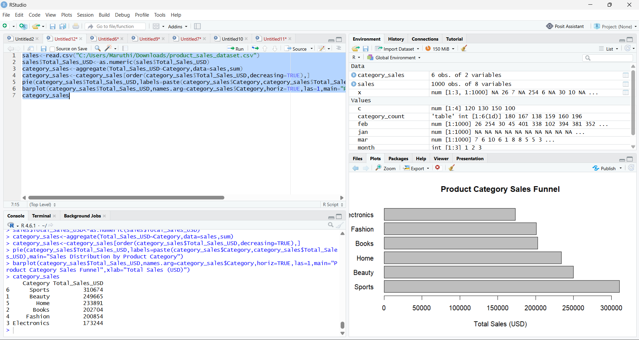RESULT
Thus, the Product Category sales data was successfully analyzed using R programming. The pie chart, funnel-style chart, and sales table were successfully created.

